CRISP-DM (Cross Industry Standard Process for Data Mining) Methodology
The CRISP-DM methodology consists of a cyclical sequence of phases commonly used by data mining experts for traditional business intelligence (BI) data mining and data strategy development. Figure 3 (below) summarizes this cycle, which is dynamic, features bidirectional movement between the six phases, and entails multiple iterations. In the diagram:
- The Iterative CRISP-DM process is shown in the outer circle.
- The most significant dependencies between phases are shown.
- Subsequent phases depend on results from the preceding phases.
- Returning to earlier phases is possible before moving forward.
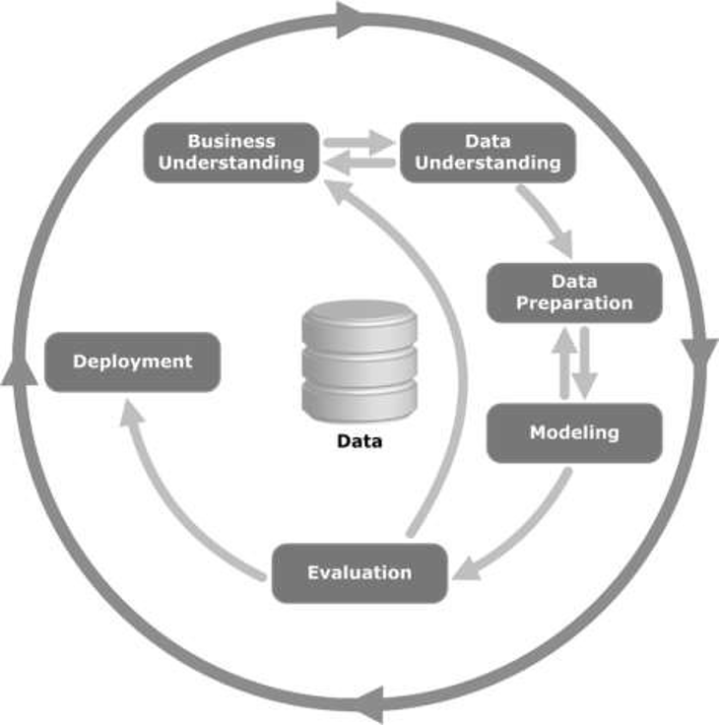
Image source: https://commons.wikimedia.org/wiki/File:CRISP-DM_Process_Diagram.png
Figure 3: The CRISP-DM process
Specific activities for each phase are highlighted below:

Business/Research Understanding Phase (Figure 4)
- Define project requirements and objectives
- Translate objectives into a data mining problem definition
- Prepare a preliminary strategy to meet the objectives
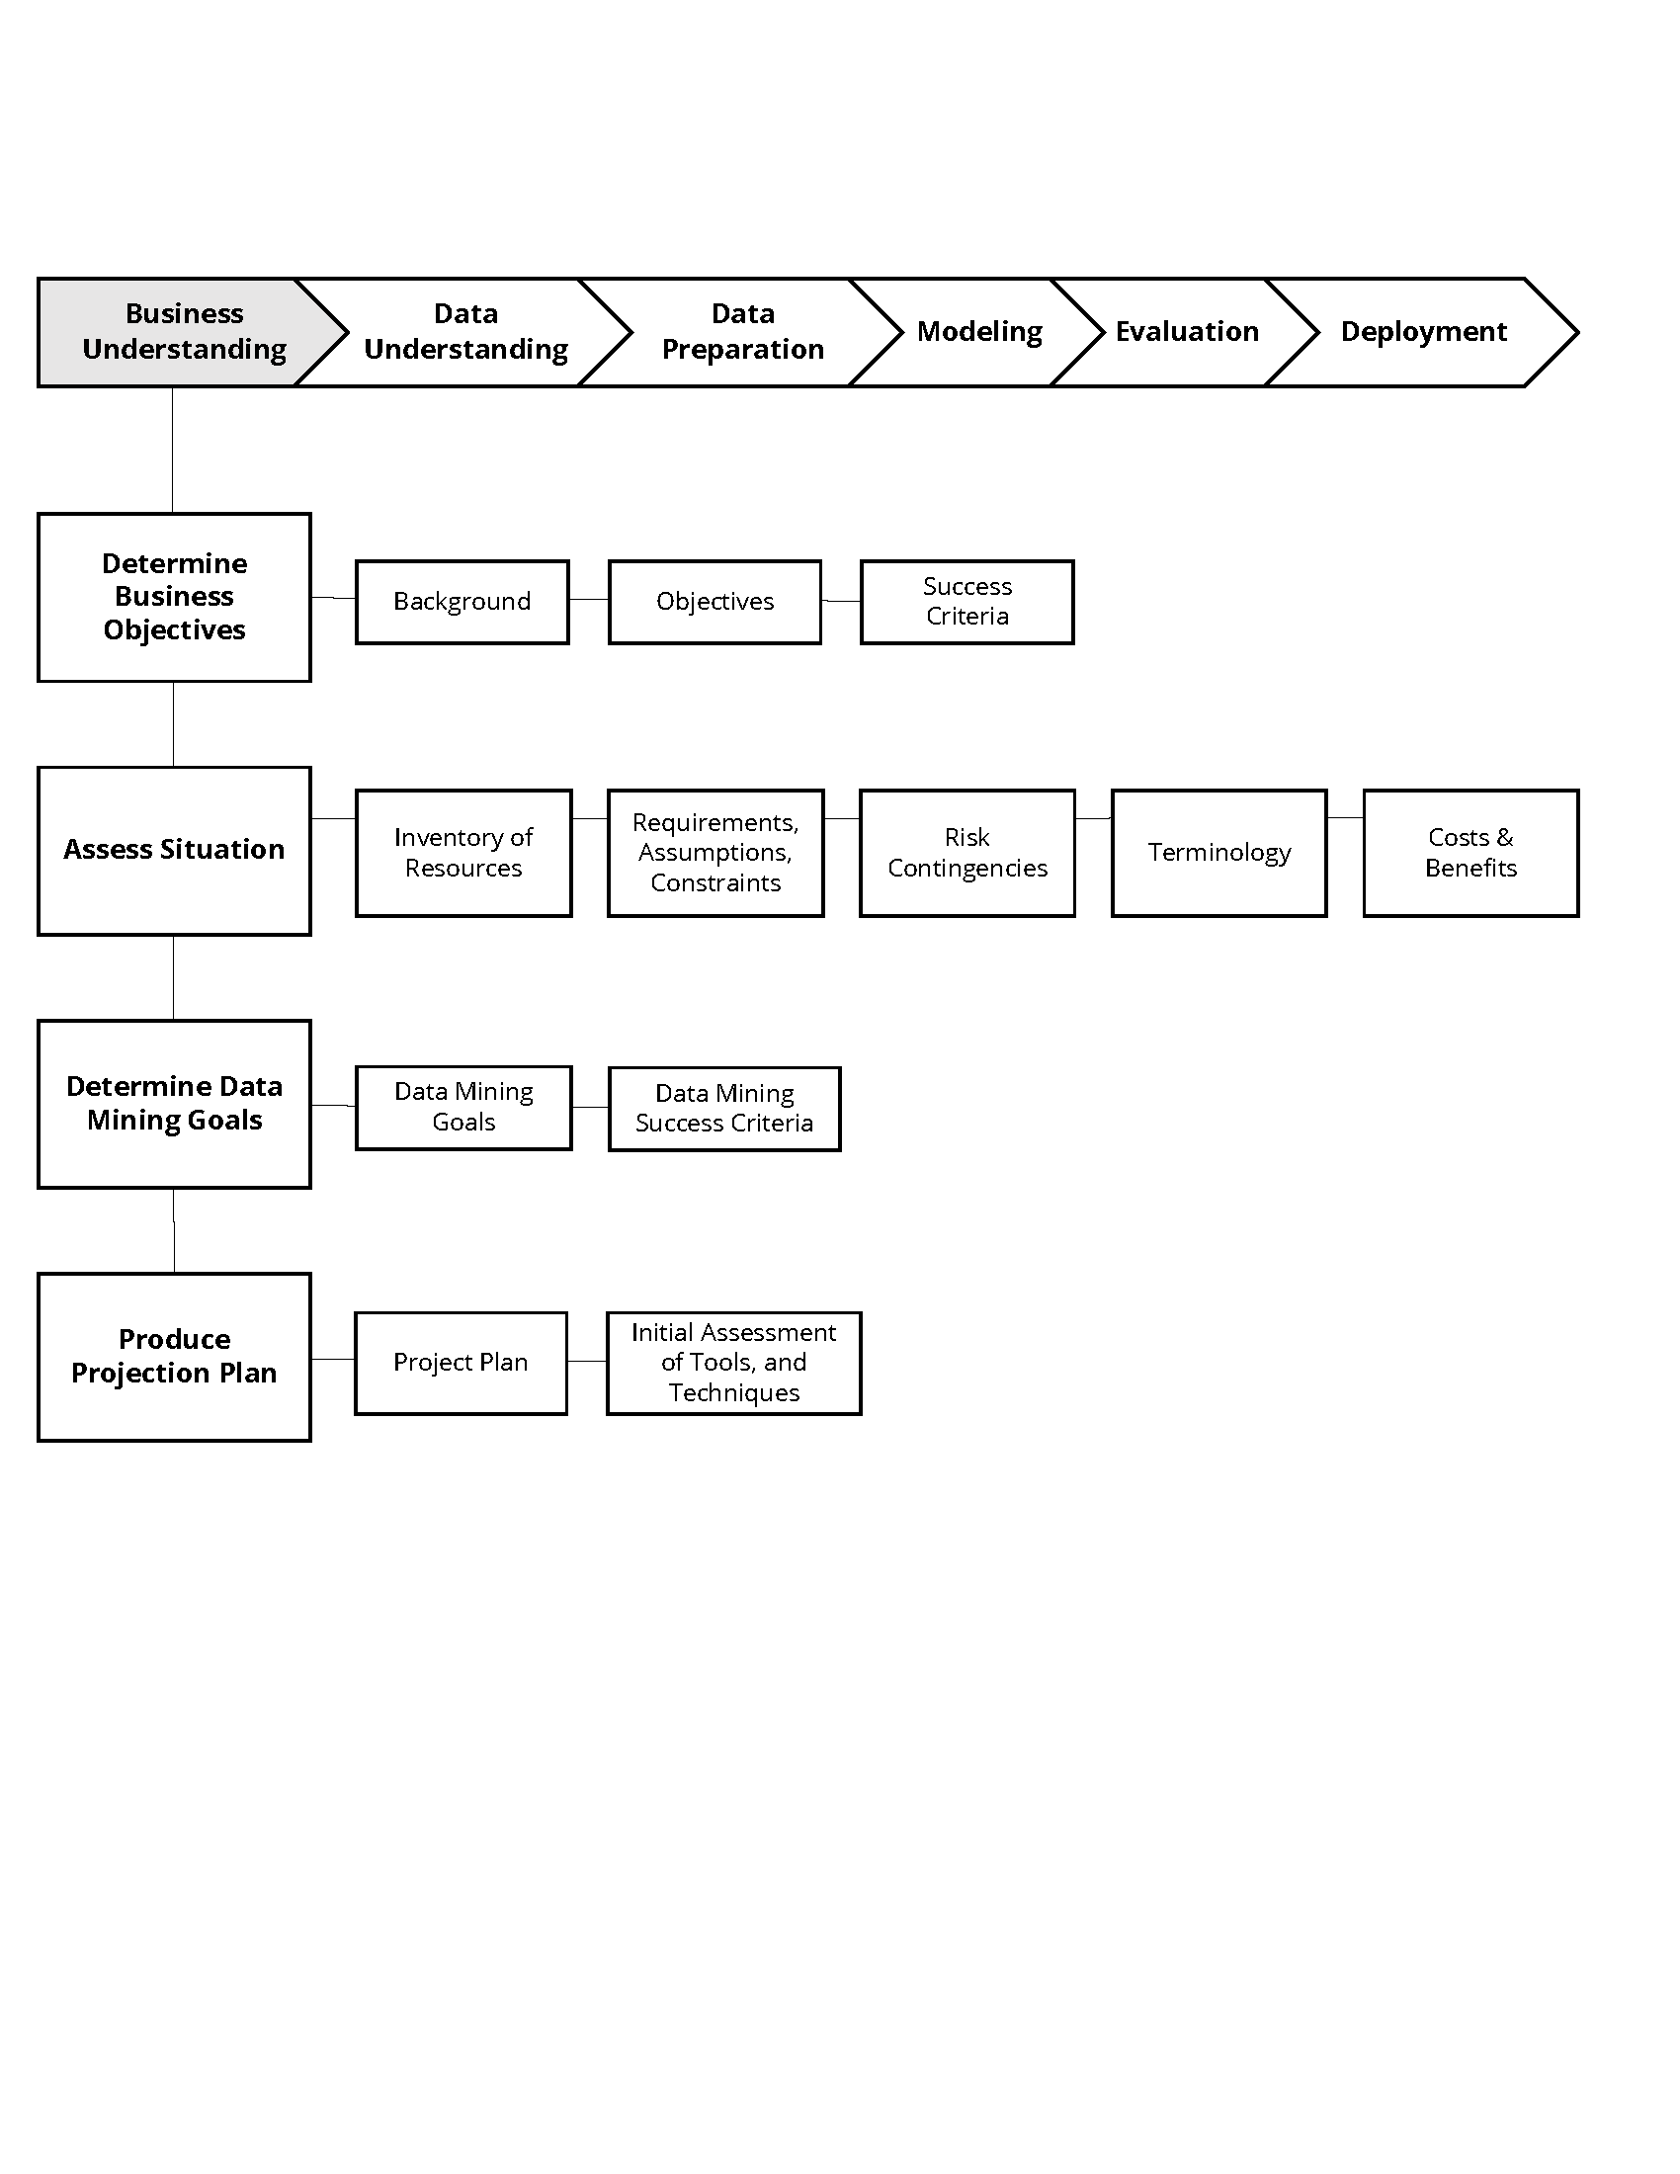
Figure 4: The business understanding phase

Data Understanding Phase (Figure 5)
- Collect data
- Perform exploratory data analysis (EDA)
- Assess data quality
- Select

